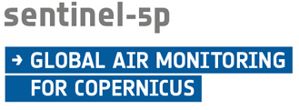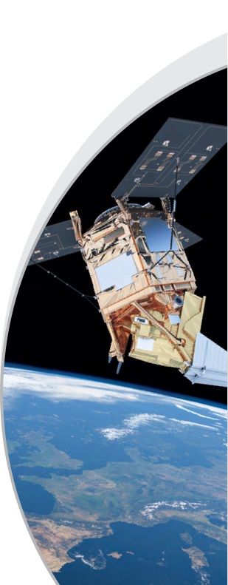

***Mission Status Report 141***

***Reference Period: 16-31 Aug. 2023***

***Mission Status***

Overall

* The mission, in Phase E2 (Operations Phase) since 24th April 2018, has reached routine operations capacity at the beginning of March 2019.

Operational Products availability and access

* Level 1B Radiance/Irradiance, Level 2 Methane, Tropospheric Ozone (Offline); Aerosol Absorbing Index, Aerosol Layer Height, Carbon Monoxide, Cloud, Formaldehyde, Nitrogen Dioxide, Ozone Profile, Sulphur Dioxide, and Total Ozone products (Offline and Near Real Time) are available to the public via the Copernicus Sentinel-5 Precursor Data Hub – <https://s5phub.copernicus.eu>.

Platform

* Orbit Control Manoeuvre (OCM) activities were executed on 30th August between 18:17 – 19:02 with no noticeable impact on the quality of the data.

TROPOMI Payload

* The TROPOMI instrument continues measuring in nominal operations baseline with a 360 orbit repeat cycle and since 6th August 2019 with a spatial resolution of about 5.5 km along-track and 3.5 km across-track.

Ground Segment

* The status of both Flight Operations Segment (FOS) and Payload Data Ground Segment (PDGS) has been nominal. Routine scheduling, acquisition, processing, and dissemination tasks were performed without major anomalies.
* Regarding the forest fires that have damaged parts of the communication network at the Inuvik ground station (impacting only the Near Real Time service) on 7th August: the areas where the fibre has been compromised have been identified and repair work has started.

Level 1B / Level 2 processors

* The KNMI and DLR teams are working on updated/improved Level 2 processors (e.g. new Methane retrieval algorithm) that will be implemented in the operational PDGS until end November 2023.

Cal/Val Activities

* The routine validation activities continued nominally for all products.

PAL Activities

* Six pre-operational products (Aerosol Optical Thickness, Bromine Monoxide, Glyoxal, Sun-Induced Fluorescence, Water Vapour, and a Sulphur Dioxide product using the new Covariance-Based Retrieval Algorithm (COBRA)) are being provided to the public via <https://data-portal.s5p-pal.com>.

***Outlook***

* The data access for all Copernicus products is being transferred to the new Copernicus Data Space Ecosystem. It is expected that the access for Sentinel-5P data will be provided by this new Ecosystem after end September 2023.

*Report prepared by the ESA Sentinel-5 Precursor Team*