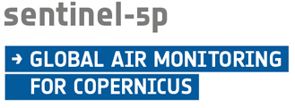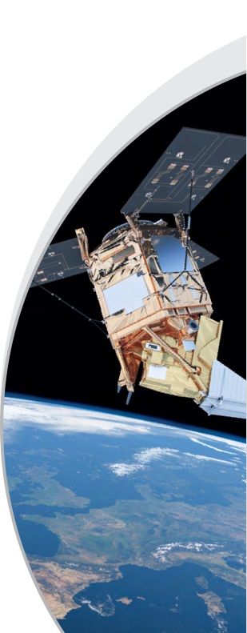

***Mission Status Report 140***

***Reference Period: 01-15 Aug. 2023***

***Mission Status***

Overall

* The mission, in Phase E2 (Operations Phase) since 24th April 2018, has reached routine operations capacity at the beginning of March 2019.

Operational Products availability and access

* Level 1B Radiance/Irradiance, Level 2 Methane, Tropospheric Ozone (Offline); Aerosol Absorbing Index, Aerosol Layer Height, Carbon Monoxide, Cloud, Formaldehyde, Nitrogen Dioxide, Ozone Profile, Sulphur Dioxide, and Total Ozone products (Offline and Near Real Time) are available to the public via the Copernicus Sentinel-5 Precursor Data Hub – <https://s5phub.copernicus.eu>

Platform

* All platform subsystems performed nominally.

TROPOMI Payload

* The TROPOMI instrument continues measuring in nominal operations baseline with a 360 orbit repeat cycle and since 6th August 2019 with a spatial resolution of about 5.5 km along-track and 3.5 km across-track.

Ground Segment

* The status of both Flight Operations Segment (FOS) and Payload Data Ground Segment (PDGS) has been nominal. Routine scheduling, acquisition, processing and dissemination tasks were performed without major anomalies.
* Due to forest fires that have damaged parts of the communication network at the Inuvik ground station the Near Real Time service for data acquired at the Inuvik has been unavailable from 7 to 10 August. This contingency is being managed by replanning the acquisitions to use only the Svalbard station since 10th August. The data for the above period are not lost and will be processed and made available as soon as feasible as offline data.

Level 1B / Level 2 processors

* The KNMI and DLR teams are working on the Level 2 processors (e.g. new Methane retrieval algorithm) that will be implemented in the operational PDGS until November 2023.

Cal/Val Activities

* The routine validation activities continued nominally for all products.

PAL Activities

* Six pre-operational products (Aerosol Optical Thickness, Bromine Monoxide, Glyoxal, Sun-Induced Fluorescence, Water Vapour, and a Sulphur Dioxide product using the new Covariance-Based Retrieval Algorithm (COBRA)) are being provided to the public via <https://data-portal.s5p-pal.com>.

***Outlook***

* The data access for all Copernicus products is being transferred to the new Copernicus Data Space Ecosystem. It is expected that the access for Sentinel-5P data will be provided by this new Ecosystem until September 2023.

*Report prepared by the ESA Sentinel-5 Precursor Team*